**Canterbury Plunket Shield Team 1964/65**

**Winners of the Plunket Shield**

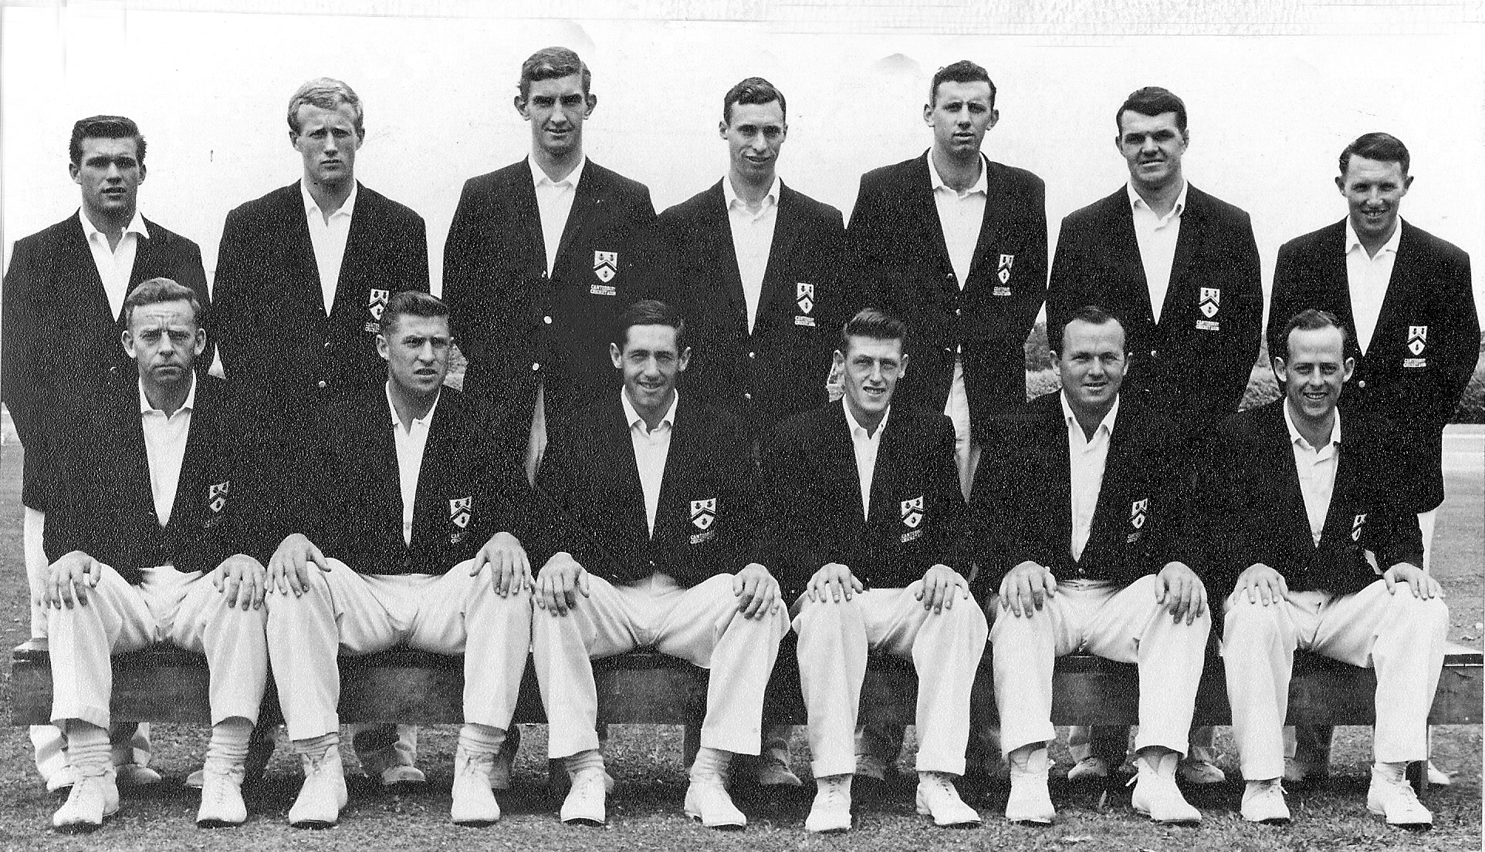

**Back Row:** RM Geary PA Sharp B Andrews BG Hadlee BRTaylor IR Hartland JR Veitch

**Front Row:** JW Kiddey RC Motz GT Dowling (captain) JT Ward K Thomson BF Hastings